 | How to choose  THE PERFECT  Sofa Wall Bed | 
No doubt, we designed the smartest space-saving furniture out there – 3in1 Sofa Wall Bed – a sofa, bed and lift-up coffee table integrated in the perfect multifunctional system.
But how to be sure that our 3in1 system is what you need? Let’s see what it will bring to you and compare it with the similar products on the market.

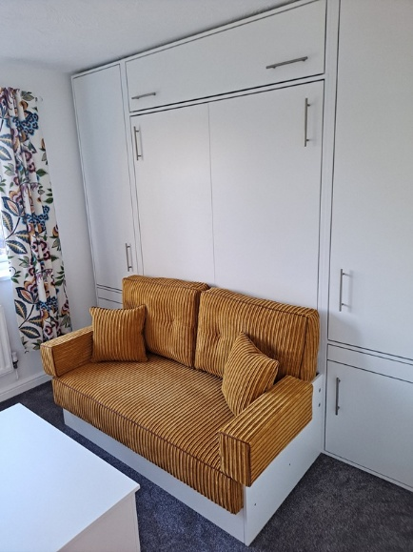 | 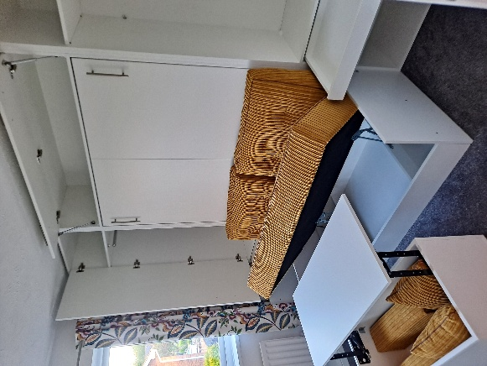 | 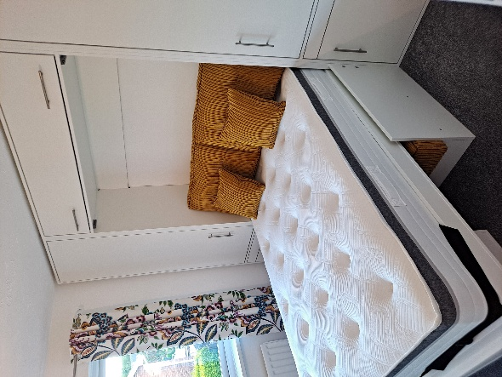

Here’s a quick list of the most important features 3in1 system offers:

- Safety first – While traditional wall beds rely solely on wall fixings that can pull away under stress, the structure of our patented system prevents this. It’s inherently safe from tipping over.
- The real mattress – you can use mattress with any size, any thickness and any weight. We simply design everything around your mattress and the strength of our patented mechanism can handle heaviest mattresses easily.
- Incorporated Lift-up coffee table – this is another super helpful patented feature. It acts as a strongest support, converts to a desk and offers lots of handy storage. Which leads us to the next feature…
- Storage audit – a standard 3in1 set comes with under the sofa seat storage, table storage and space to store the bedding when closing the bed. Additionally, there are three more storage options.

You can find the full list of features below.
Comprehensive Buyer’s Checklist
and comparison table

 | Feature/Model | 3 in 1 Sofa Wall Bed | Other sofa wall beds
 | Price | From £1490 to around £3000 | Similar to higher price range
 | Guarantee | Lifetime | 1 to 5 years
 | Safety | Maximum | Requires heavy-duty wall anchoring to prevent tipping. Not possible for plasterboard walls
 | Reliability | Maximum, designed for long term regular use | Regular use quickly degrades the characteristics, hence, 1 to 5 years guarantee only
 | Installation | Professional installation Included | Most do not offer free professional installation
 | Delivery | Free within M25, £1.50 per mile outside M25 | Some offer free delivery
 | Lead time | 2 to 3 weeks | Usually 8 to 12 weeks
 | Mattress size | All UK sizes + any custom size | Very limited mattress sizes
 | Mattress Thickness | Can accommodate 10”+ | Mostly limited to a 8” mattresses
 | Lift up coffee table | Included, convertible to a desk | Non
 | Boards quality | EGGER, KRONOSPAN and other UK/EU manufacturers.  Comply with the strictest formaldehyde emissions regulations | Unknown boards manufacturers
 | Boards choice | 300+ | Very limited
 | Fabrics choice | Any fabric on the market | Very limited
 | Upholstery finish | Standard, premium or custom | Basic designs only
 | Extra upholstery features | Throw pillows, bolster pillows, Piping, Extra buttons | Non
 | Footprint:  Small Double  Standard Double  King Size | Width x Projection  2.7 sq.m. (1.3m x 2.1m)  3 sq.m. (1.4m x 2.1m)  3.5 sq.m. (1.6m x 2.2m) | ~20% larger footprint
 | Slats | Yes, birch ply, ideal for mattress ventilation in humid climate like UK’s | Expensive models only
 | Bed height | 65 to 75cm.Matches the height of a premium hotel bed. The ideal height for natural 'sit-to-stand' motion, allowing you to wake up and step out of bed effortlessly | ~40cm, not very convenient, Requires significant physical effort to stand up, especially for heavier, older and people with limited mobility.
 | Storage: | Up to 6 places to store stuffs from 6 large suitcases | Very limited.  No customization
 | 1.Sofa seat storage | ~ two large suitcases | -
 | 2. Table storage | ~ a large and a small suitcases | -
 | 3. Inside storage | ~ a small suitcase | -
 | 4. Bedding storage | 6”+ to accommodate a duvet with two pillows belted to the mattress | 4” to 6” maximum
 | 5. Top storage | ~ two large suitcases | -
 | 6. Wide Armrests storage | ~ two small suitcases | -
 | Accessibility | Best: high bed, narrow armrests | Requires significant effort
 | Sleep Comfort | Superior – your preferred mattress | Limited due to restricted mattress thickness and weight
 | Seating Comfort | 20 cm thick soft/middle/hard seat, 25cm thick back pillows | Can’t choose seat/pillows softness.
 | Matching furniture | Yes, any custom sizes required | Very limited options

Ready to see your room transform?
Send us your dimensions and we’ll create a free space-saving plan tailored to your home.
Your 'extra' room is just a phone call away. Let’s reclaim your living space together.
Let’s build your perfect 3-in-1 system. Email us, WhatsApp us a photo of your wall or call for a free custom configuration today.
info@3in1sofawallbeds.com 07852720959

